Layout-to-JSON Workflow for Adobe InDesign Automation
1. Purpose
This guide explains how to set up the Google Cloud / Vertex AI development environment from absolute scratch. It assumes you only have:
- PowerShell terminal open
- Google Cloud Console in the browser
No projects, service accounts, IAM roles, or APIs exist yet.
Goal: Enable your team to replicate the setup reliably, prepare a private Vertex AI workspace, and connect Python code to Gemini models for structured layout JSON generation.

2. Step 1 – Create a Google Cloud Project
- Open Google Cloud Console: https://console.cloud.google.com
- Click Select a project → New Project
- Enter:
  - Project Name: indesign-layout-ai
  - Project ID: Auto-generated (or customize if allowed)
  - Location / Organization: Select your organization if prompted
- Click Create
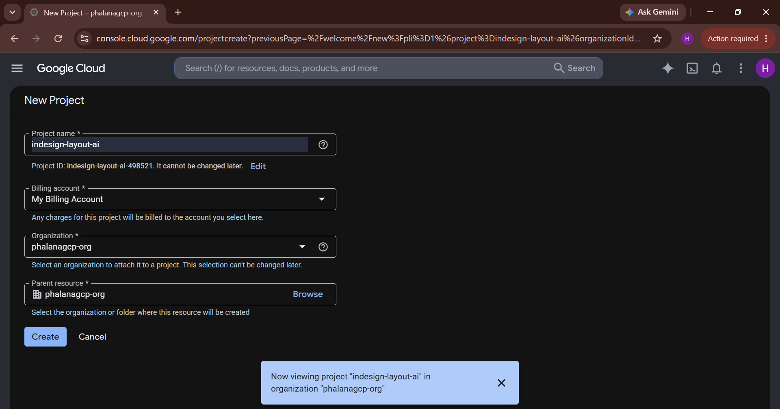

3. Step 2 – Enable Billing
- In the Cloud Console, go to Billing → Link a billing account
- Select or create a billing account
- Link it to your new project
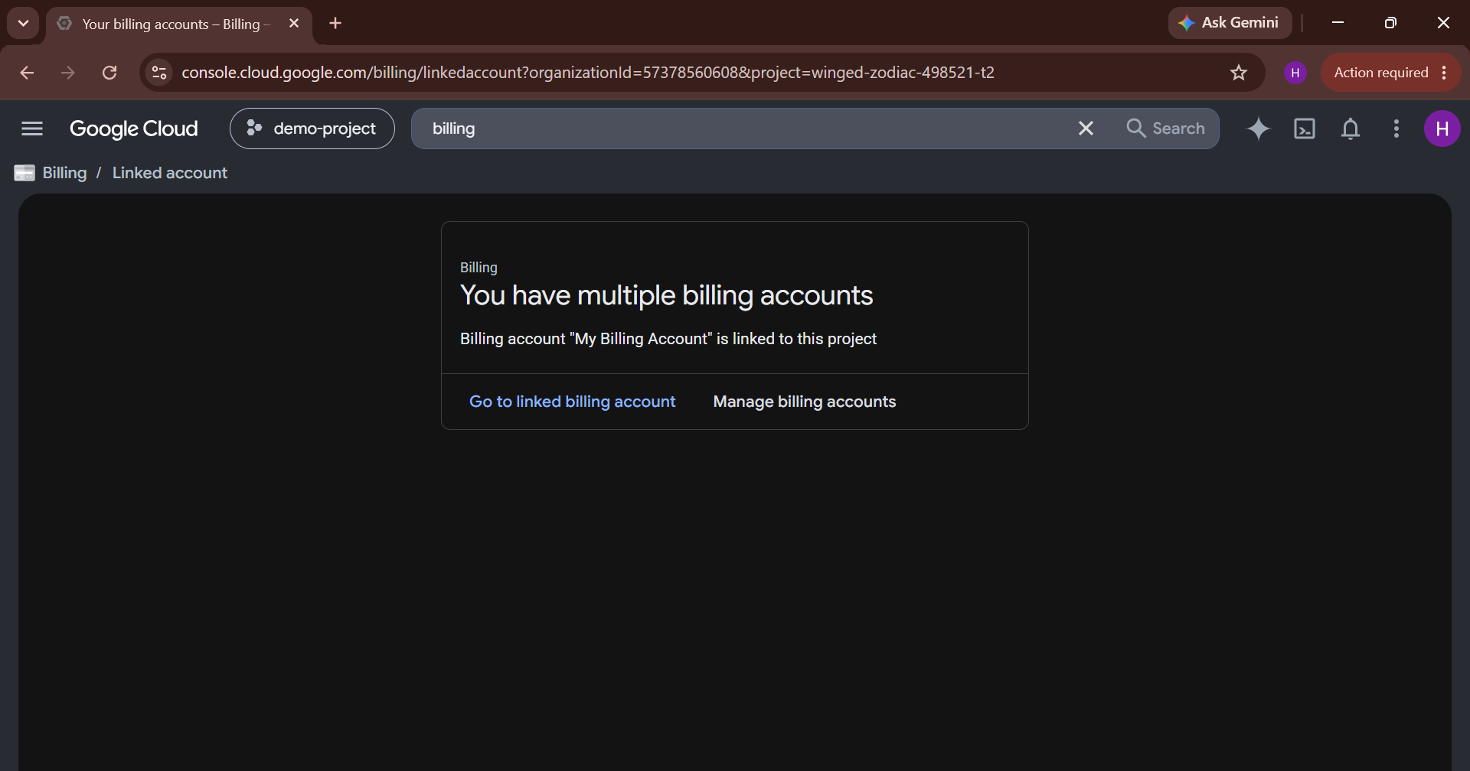

4. Step 3 – Install Google Cloud CLI
- Download Google Cloud CLI: https://cloud.google.com/sdk/docs/install
- Install it (choose bundled Python if asked)
- Open PowerShell and verify:
gcloud --version
Expected output:
Google Cloud SDK [version]
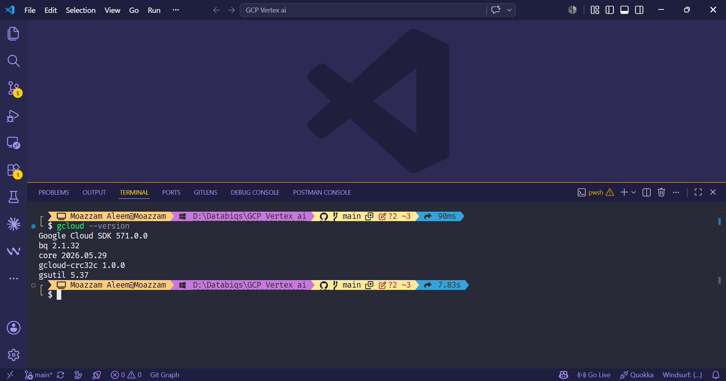
5. Step 4 – Login and Set Project
Login with your Google account that will have Owner privileges:
gcloud auth login
- A browser window opens. Sign in.
- Then set the project:
gcloud config set project indesign-layout-ai
- Verify:
gcloud config get-value project
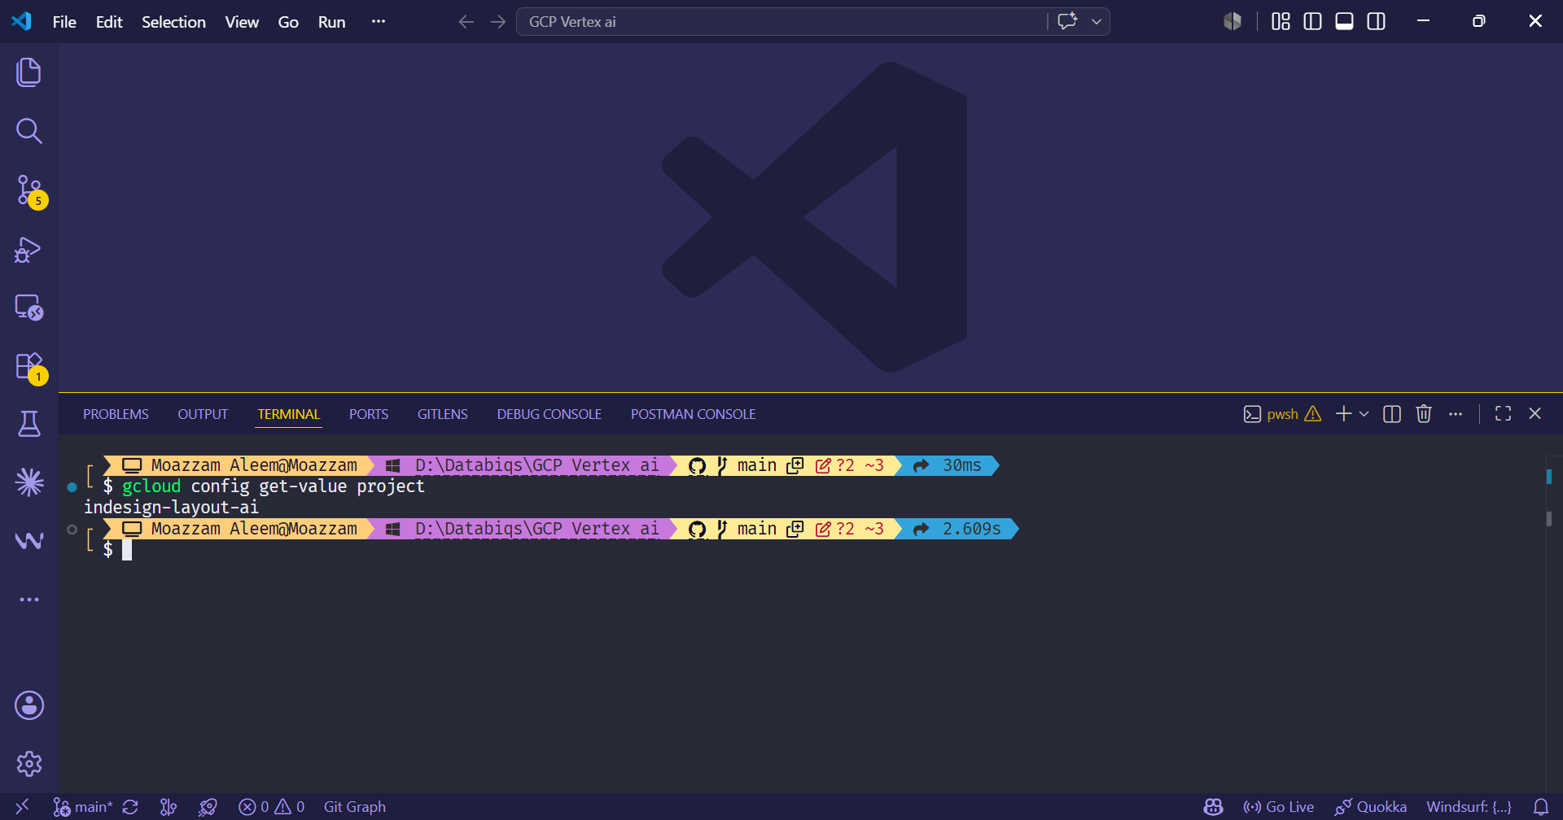
6. Step 5 – Enable Required APIs
Enable APIs necessary for Vertex AI, IAM, and Cloud Storage:
gcloud services enable `
aiplatform.googleapis.com `
iam.googleapis.com `
storage.googleapis.com `
cloudresourcemanager.googleapis.com `
serviceusage.googleapis.com

7. Step 6 – Create a Service Account
Service account will allow Python scripts to connect securely.
gcloud iam service-accounts create vertex-layout-dev-sa `
--description="Service account for Vertex AI development" `
--display-name="Vertex Layout Dev SA"
Wait 1 minute before using it.

7. Step 7 – Assign IAM Roles (Updated for Existing Service Account)
Since the service account already exists as:
layout-pipeline-dev@indesign-layout-ai.iam.gserviceaccount.com
You can assign the required roles via CLI to match what you did in the console.
7.1 PowerShell
$SA_EMAIL="layout-pipeline-dev@indesign-layout-ai.iam.gserviceaccount.com"
# Grant Agent Platform User
gcloud projects add-iam-policy-binding indesign-layout-ai `
--member="serviceAccount:$SA_EMAIL" `
--role="roles/aiplatform.user"
# Grant AI Platform Admin
gcloud projects add-iam-policy-binding indesign-layout-ai `
--member="serviceAccount:$SA_EMAIL" `
--role="roles/aiplatform.admin"
# Grant Storage Object Admin
gcloud projects add-iam-policy-binding indesign-layout-ai `
--member="serviceAccount:$SA_EMAIL" `
--role="roles/storage.objectAdmin"
7.2 Command Prompt (Windows)
set SA_EMAIL=layout-pipeline-dev@indesign-layout-ai.iam.gserviceaccount.com
gcloud projects add-iam-policy-binding indesign-layout-ai ^
--member="serviceAccount:%SA_EMAIL%" ^
--role="roles/aiplatform.user"
gcloud projects add-iam-policy-binding indesign-layout-ai ^
--member="serviceAccount:%SA_EMAIL%" ^
--role="roles/aiplatform.admin"
gcloud projects add-iam-policy-binding indesign-layout-ai ^
--member="serviceAccount:%SA_EMAIL%" ^
--role="roles/storage.objectAdmin"
Notes:
- roles/aiplatform.user → access to use Vertex AI resources
- roles/aiplatform.admin → full AI Platform access
- roles/storage.objectAdmin → full control over Cloud Storage objects
Running these commands is safe even if the roles are already assigned. GCP will ignore duplicates.

9. Step 8 – Create Service Account Key
- Make config folder:
mkdir config
- Generate key:
gcloud iam service-accounts keys create config/gcp-sa-key.json `
--iam-account=$SA_EMAIL
- Wait 60 seconds before using the key.
Security note: Never commit this file to GitHub. Add config/gcp-sa-key.json to .gitignore.
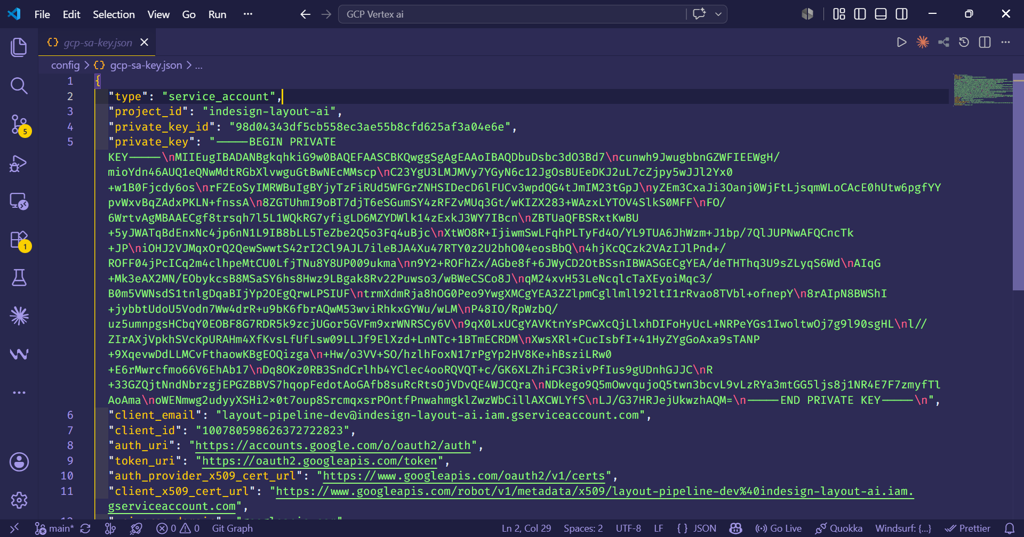

10. Step 9 – Create Cloud Storage Workspace Bucket
gcloud storage buckets create gs://indesign-layout-ai-workspace `
--location=us-central1 `
--uniform-bucket-level-access `
--public-access-prevention
Recommended folder structure inside the bucket:
raw_samples/
normalized_data/
prompt_library/
special_cases/
generated_outputs/
validation_reports/
archived_runs/
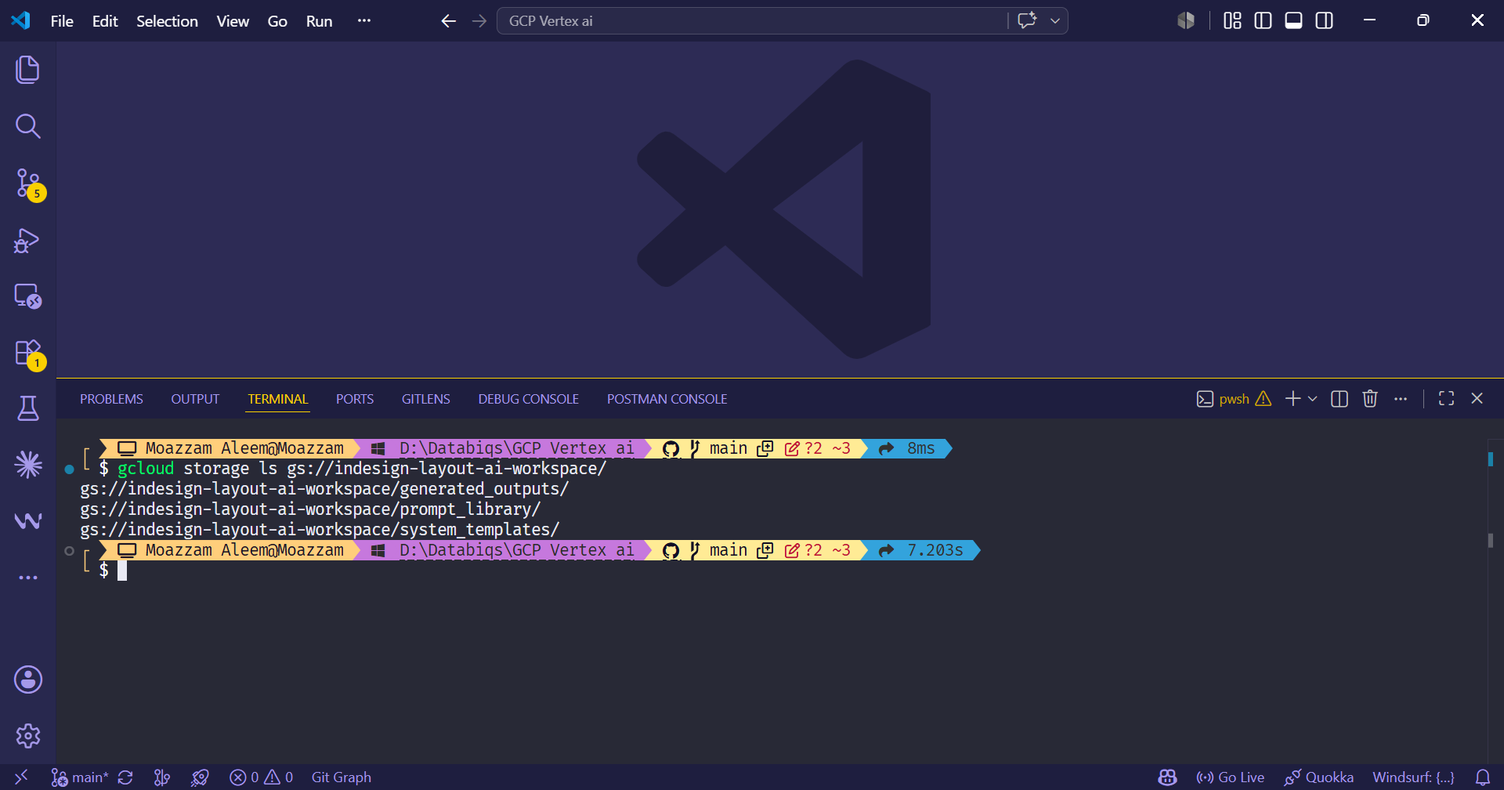
11. Step 10 – Python Environment Setup
- Create virtual environment:
python -m venv .venv
.venv\Scripts\activate
- Upgrade pip:
python -m pip install --upgrade pip
- Install packages:
pip install google-genai google-cloud-storage pydantic python-dotenv

12. Step 11 – Set Environment Variables
PowerShell:
$env:GOOGLE_APPLICATION_CREDENTIALS="config/gcp-sa-key.json"
$env:GOOGLE_CLOUD_PROJECT="indesign-layout-ai"
$env:GOOGLE_CLOUD_LOCATION="us-central1"
$env:GOOGLE_GENAI_USE_VERTEXAI="true"
Command Prompt:
set GOOGLE_APPLICATION_CREDENTIALS=config\gcp-sa-key.json
set GOOGLE_CLOUD_PROJECT=indesign-layout-ai
set GOOGLE_CLOUD_LOCATION=us-central1
set GOOGLE_GENAI_USE_VERTEXAI=true

13. Step 12 – Test Vertex AI Connection
Create tests/test_vertex_ai_connection.py:
from google import genai
import os

client = genai.Client(
vertexai=True,
project=os.getenv("GOOGLE_CLOUD_PROJECT"),
location=os.getenv("GOOGLE_CLOUD_LOCATION")
)

regional_model = f"projects/{os.getenv('GOOGLE_CLOUD_PROJECT')}/locations/{os.getenv('GOOGLE_CLOUD_LOCATION')}/publishers/google/models/gemini-2.5-flash"

response = client.models.generate_content(
model=regional_model,
contents="Hello Vertex AI!"
)

print(response.text)
Run:
python scripts/test_vertex_ai_connection.py
Expected output:
Hello Vertex AI!
